Functional First World Hotel Digital Twin Prototype

By Loh Yong Xuan

Executive Summary
The hospitality industry is increasingly adopting Industry 4.0 technologies to enhance operational efficiency and customer engagement. This report details the development of a functional Digital Twin prototype for the First World Hotel, designed to bridge the gap between static digital presentations and physical hotel operations.
The primary objective of this project was to create a dynamic, spatial interface that integrates real-time data visualization with high-fidelity 3D modelling. Utilizing the Unity 3D game engine for visualization and the MQTT protocol for lightweight messaging, the system successfully demonstrates a continuous data flow between a backend Python publisher and a frontend client.
Key features of the prototype include:
- Real-Time Simulated Data Integration: The system visualizes simulated operational metrics (foot traffic, room availability) and live environmental data (weather, temperature) fetched via the Open-Meteo API.
- Interactive Exploration: A First-Person-View (FPV) mode allows users to virtually navigate room layouts, addressing the limitations of traditional 2D booking photographs.
- Scalable Architecture: The backend utilizes a local Mosquitto broker, establishing a proof of concept for future integration with live IoT sensor networks.
This project serves as a foundational step for Genting’s facilities monitoring capabilities. It validates that complex operational correlations can be effectively monitored in a 3D environment, offering a modernized approach to both guest experience and asset management.

Table of Contents
Executive Summary 2
Table of Figure 4
1 Introduction 5
1.1 Project Overview 5
1.2 Problem Statement 6
1.3 Objectives 6
2 Tools and Technologies Used 7
2.1 Tools Used 7
2.2 Technologies Used 7
3 Backend Architecture 8
3.1 Mathematical Logic 8
4 Frontend Functionality 9
4.1 Main Menu Scene 9
4.2 Hotel Room Layout Scene 10
5 Gantt Chart 16
6 Future Improvement and Recommendation 17
6.1 Integration of Live IoT Sensor Infrastructure 17
6.2 Development of High-Fidelity, True-to-Scale Interiors 17
6.3 Expansion of Environmental and Geospatial Context 17
7 Conclusion 18
8 References 19

Table of Figure
Figure 4.1 9
Figure 4.2 9
Figure 4.3 10
Figure 4.4 11
Figure 4.5 11
Figure 4.6 12
Figure 4.7 12
Figure 4.8 13
Figure 4.9 13
Figure 4.10 14
Figure 4.11 14
Figure 4.12 15
Figure 4.13 15
Figure 5.1 16

Introduction
A Digital Twin (DT) is fundamentally defined as a dynamic, virtual replica of a physical system, asset, or environment that reflects its real-world counterpart in real-time. Unlike a traditional static 3D model, a Digital Twin is distinguished by a continuous, bidirectional data flow between the physical and digital states. According to Attaran and Celik (2023), this technology integrates advanced components such as the Internet of Things (IoT), Artificial Intelligence (AI), and Big Data analytics to monitor, simulate, and optimize system performance. This capability allows the digital entity to evolve alongside its physical twin, providing a comprehensive view of current operations.
In the context of the built environment and Industry 4.0, Digital Twins serve as a critical bridge between physical infrastructure and virtual management. They enable operators to visualize "invisible" data, such as structural stress, energy usage patterns, or thermal conditions, directly onto a spatial model, facilitating predictive maintenance and informed decision-making. Research by Sepasgozar et al. (2023) emphasizes the growing role of DTs in the construction sector, where they are utilized to manage the entire lifecycle of a building, from the initial design and construction phases through to daily operation and maintenance.
The effectiveness of a Digital Twin relies heavily on its connectivity and speed of data transmission. Al-Sehrawy et al. (2024) highlight that integrating real-time sensor data via lightweight protocols like MQTT is essential for these systems to reflect the "live" status of an asset accurately. By doing so, Digital Twins are transformed from passive archival models into active management tools that can respond to environmental changes instantly. This project applies these principles to the hospitality sector, leveraging Unity 3D and MQTT to create a responsive Digital Twin prototype for the First World Hotel.

Project Overview
This project focuses on the design and implementation of a functional Digital Twin prototype for the First World Hotel, aiming to bridge the gap between physical hotel operations and digital visualization. The core goal is to move beyond static data presentation by integrating real-time operational metrics into a dynamic, spatial interface. The twin is primarily built using the Unity 3D game engine for high-fidelity visualization, seamlessly linked to a backend communication system via the MQTT protocol. This integration transforms raw data into an interactive 3D environment, establishing a functional proof of concept for advanced facilities monitoring within Genting operations.
The prototype’s architecture is structured to simulate a full-scale IoT environment. A Python script serves as the data publisher, generating simulated operational parameters, including foot traffic, and room availability, with mathematical logic applied to ensure data consistency and correlation. Concurrently, real-time environmental data, including weather condition and temperature, are sourced from the free Open-Meteo API. All data streams are transmitted as JSON payloads through a local Mosquitto broker. The Unity C# client functions as the subscriber, listening for these messages and dynamically updating the 3D model and associated user interface (UI) elements.
The resultant system offers two primary user interfaces. The Main Menu Scene, which presents an overview of the entire hotel with key performance indicators (KPIs) and environmental updates. The Hotel Room Layout Scene, which allows interactive, First-Person-View (FPV) exploration of individual room types. This comprehensive, interactive visualization allows management to observe complex correlations in context, validating a modern, efficient, and data-driven approach to facilities monitoring.

Problem Statement
For potential guests of the First World Hotel, selecting the right accommodation can be a challenging experience due to the limitations of traditional booking interfaces. Most hotel websites and travel apps present room options using only static 2D photographs and brief text descriptions. These conventional methods often fail to convey the true spatial layout, scale, and "feel" of a room. Guests may struggle to visualize the difference between various room categories, such as a "Standard Room" versus a "World Club Room", leading to uncertainty about whether the space meets their specific needs or expectations regarding size and amenities.
This disconnect between digital presentation and physical reality can lead to a gap in customer expectations. Without an interactive way to explore the environment, guests cannot verify the layout or view the room from different angles, which is particularly important for a high-volume hotel with diverse room configurations. Furthermore, static booking sites lack real-time context; they do not provide immediate situational awareness of the destination, such as current weather conditions or crowd levels (foot traffic). There is a clear need for a modernized, interactive platform that bridges this gap, allowing customers to virtually "visit" and familiarize themselves with the hotel rooms and current environment prior to booking.

Objectives
- To design and develop a functional digital twin prototype for First World Hotel that integrates Unity 3D technology with the MQTT communication.
- To transform the raw operational data into 3D visualisation for more efficient monitoring compared to traditional text-based method.
- To enhance the user exploration experience by implementing a First-Person-View (FPV) interface that allows for realistic navigation of room layouts.
- To establish a scalable technical framework that validates the feasibility of integrating IoT data streams into a 3D environment for future facility management.

Tools and Technologies Used
This project utilized a specific set of software tools and underlying technologies to build the Digital Twin. Tools refer to the software applications and platforms used for development, while Technologies refer to the programming languages, protocols, and APIs that power the system's logic and communication.

Tools Used
Tools (Software) | Description
Unity (Version 2022.3.62f3) | The primary game engine used for rendering the 3D environment, handling user input, and managing the UI.
Visual Studio 2022 | The Integrated Development Environment (IDE) used for writing and debugging the C# scripts for the Unity client.
Visual Studio Code | The source code editor used to write and execute the Python script that simulate backend data and publish MQTT messages.
Mosquitto broker | An open-source message broker that implements the MQTT protocol, installed on the localhost to act as the bridge between the Python publisher and Unity subscriber.
3D Warehouse | The web-based repository used to source the base 3D model of the First World Hotel, which was then optimized for Unity.

Technologies Used
Technologies | Description
C# (C Sharp) | The object-oriented programming language used within Unity to script the behaviour of UI elements, interaction, camera movement, and MQTT subscription logic.
Python | The scripting language used to create the data publisher, which generates random operational data and JSON payloads.
MQTT Protocol | The lightweight messaging protocol (Machine-to-Machine) used for real-time bidirectional data transmission between the backend and frontend.
Open-Meteo API | A RESTful API technology used to fetch real-time environmental data (weather and temperature) via HTTP requests without requiring an API Key.

Backend Architecture
The backend architecture consists of three main components: the MQTT broker, Data Simulation and Unity Client. The localhost Mosquitto broker serves as the MQTT broker, acting as a bridge between the publisher and the subscriber.
Operational data, including “Foot Traffic”, “Parking Capacity”, “Energy Use”, is simulated using a Random function in Python script. This Python script functions as the publisher, sending data as a JSON payload to the localhost Mosquitto broker.
Environmental data such as weather condition and temperature are not simulated but obtained via a Request URL from Open-Meteo, a free and open-source API that does not require an API Key for non-commercial use. Once the data is retrieved, it is published to the localhost MQTT broker.
A C# script attached to the Unity project functions as the subscriber, connecting to the localhost to listen for the incoming messages, and dynamically update the UI elements in the sidebar.

Mathematical Logic
Mathematical logic is applied within the script to ensure the consistency of the simulated data. The Energy Use and Parking Capacity are directly proportional to the Foot Traffic. Both of the Energy Use and Parking Capacity data increase proportionally as Foot Traffic data increase.
The Rooms Available data is negatively correlated to the Foot Traffic data. The system uses a linear logic where room availability decreases by a factor of 0.6 for every unit increase in foot traffic, reflecting the correlation that higher visitor numbers result in higher occupancy.

Frontend Functionality

Main Menu Scene
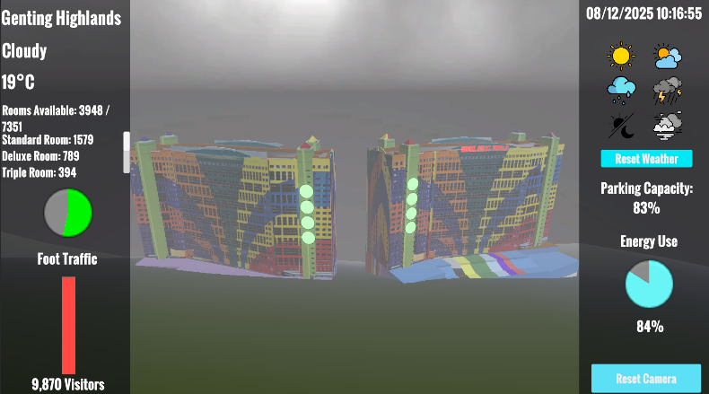
Figure 4.1
The main User Interface (UI) of the project is divided into three parts. The sidebars display the data fetched from the MQTT broker and include 6 icons representing 5 types of weather which are Sunny, Cloudy, Raining, Thunderstorm, and Fog, and a Day and Night time changer. Clicking on the icon will manually override the real-time weather, and will reset only after the user clicks the “Reset Weather” button.
The centre of the scene is the First World Hotel 3D model. User can rotate the model by holding the Left Mouse Button or reset back the camera to original position using the “Reset Camera” button.
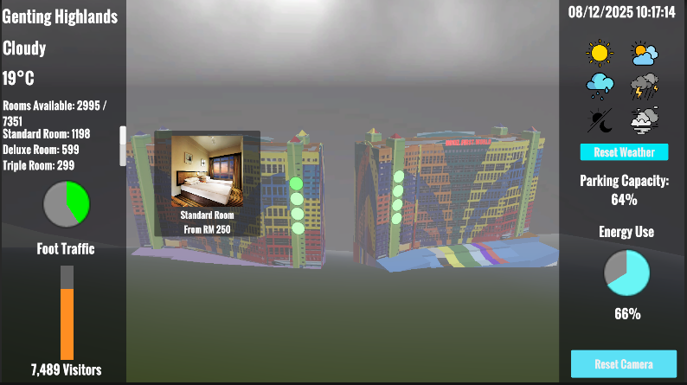
Figure 4.2
Eight interactive buttons attached to the First World Hotel 3D model represent the 8 types of hotel room that currently available, including Standard Room, Deluxe Room, Triple Room, World Club Room, World Club Room 2, Superior Deluxe Room, Y5 Deluxe Room, and Y5 Triple Room. A tooltip appears when the user hovers the cursor over a button. The tooltip included the general information of the hotel room, such as the room image, name, and the price. Clicking the button will navigate the user to the Hotel Room Layout Scene.

Hotel Room Layout Scene

Figure 4.3
In the Hotel Room Layout Scene, user view specific hotel room layout selected, using “WASD” Keys and holding Right Mouse Button for the camera movement. A toolbar exist at the bottom contains four icons with difference functions, which are “Reset Ceiling”, “Day/Night”, “FPV” (First-Person-View), and “Back”.

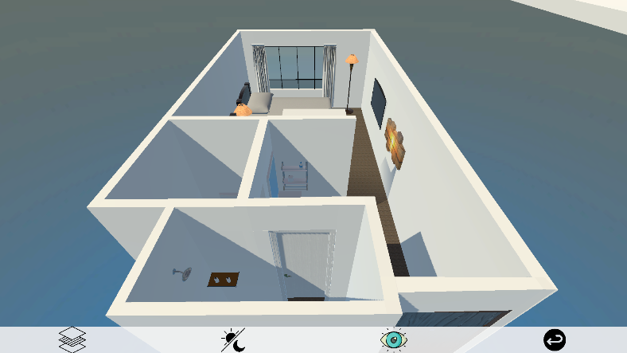
Figure 4.4
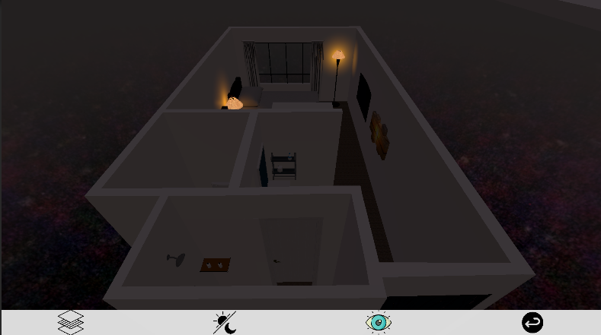
Figure 4.5
User can view the interior in 2 ways. By clicking the ceiling to lift it up, user can view the interior in Third-Person-View, with “WASD” Keys and holding Right Mouse Button for camera moving. User can toggle between Day and Night using the icon.

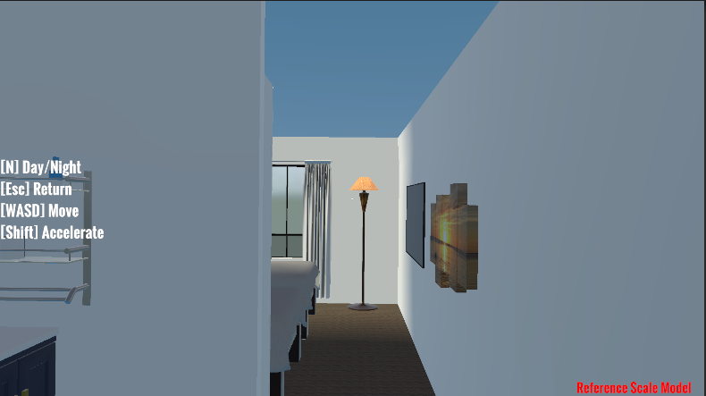
Figure 4.6
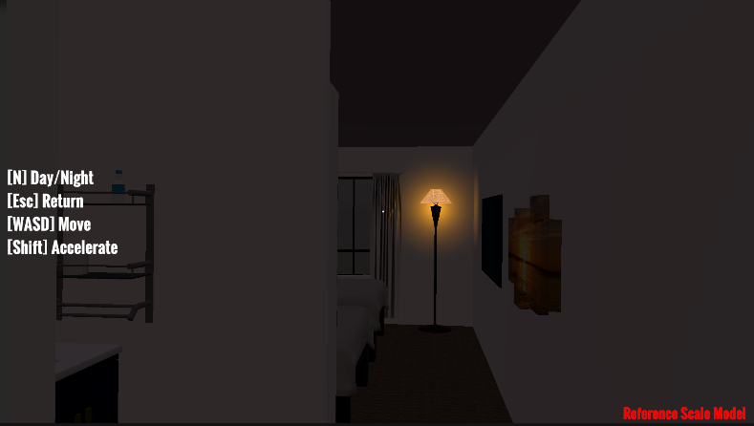
Figure 4.7
By clicking the “FPV” button, user would appear at the main entrance. In FPV mode, user move with “WASD” and look around using the mouse. User can also toggle between Day and Night with the “N” Key in FPV mode.
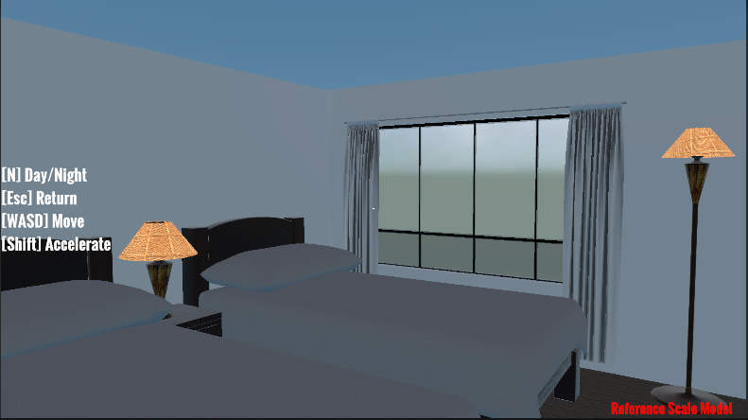
Figure 4.8
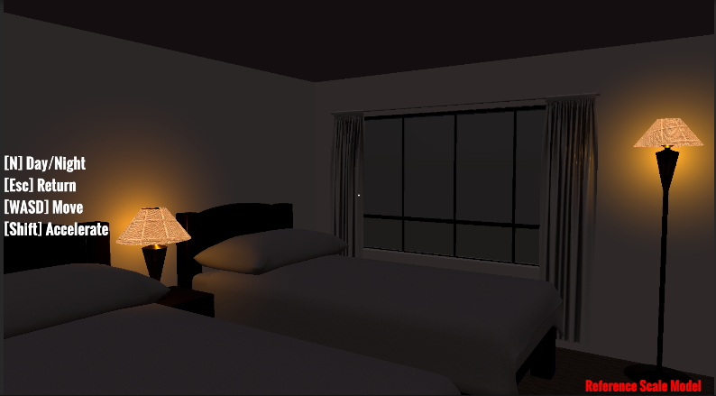
Figure 4.9
All room lighting activates automatically during night cycle.

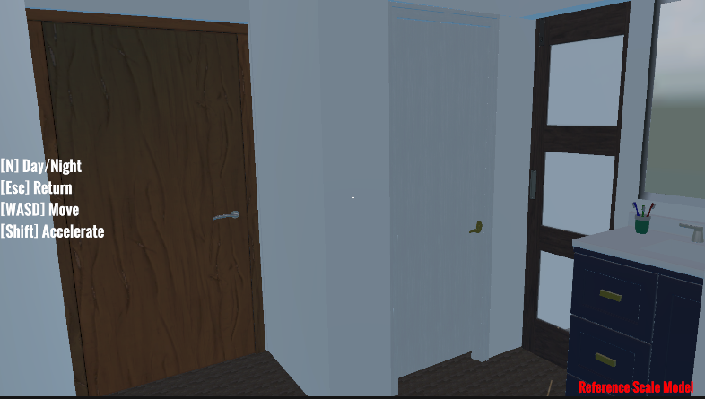
Figure 4.10
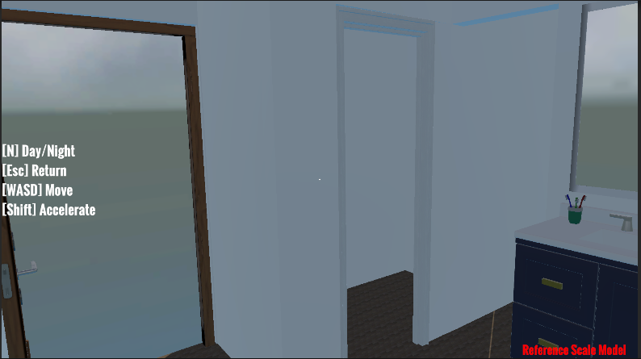
Figure 4.11
Furthermore, users can interact with the environment, all the door within the hotel room can be opened.

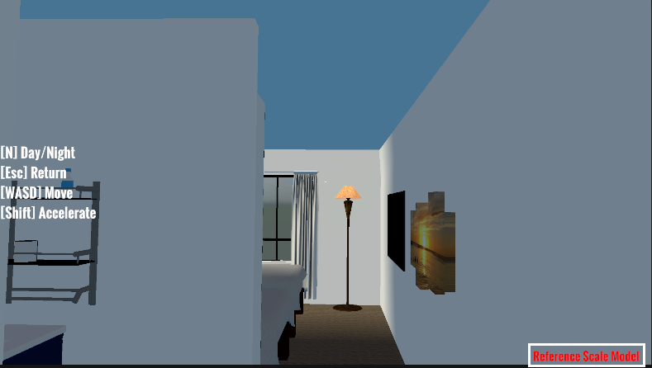
Figure 4.12
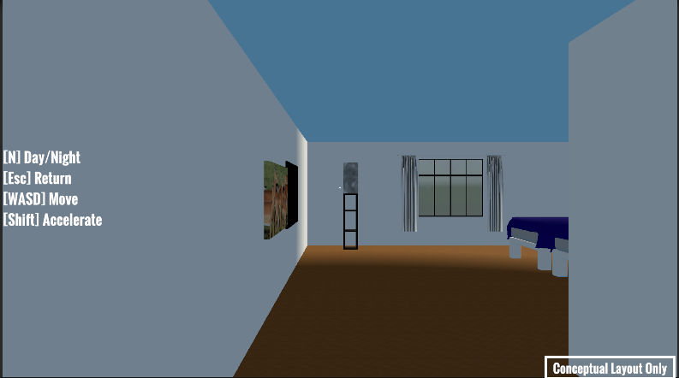
Figure 4.13
An annotation labelled “Reference Scale Model” is displayed in red for the Standard Room, indicating that the room is built to the actual physical dimensions of the hotel, although the interior design does not replicate the real-world layout. For other room types, the label “Conceptual Layout Only” is shown in white, signifying that both the room size and interior are for reference purposes only and are not based on actual hotel specifications.

Gantt Chart
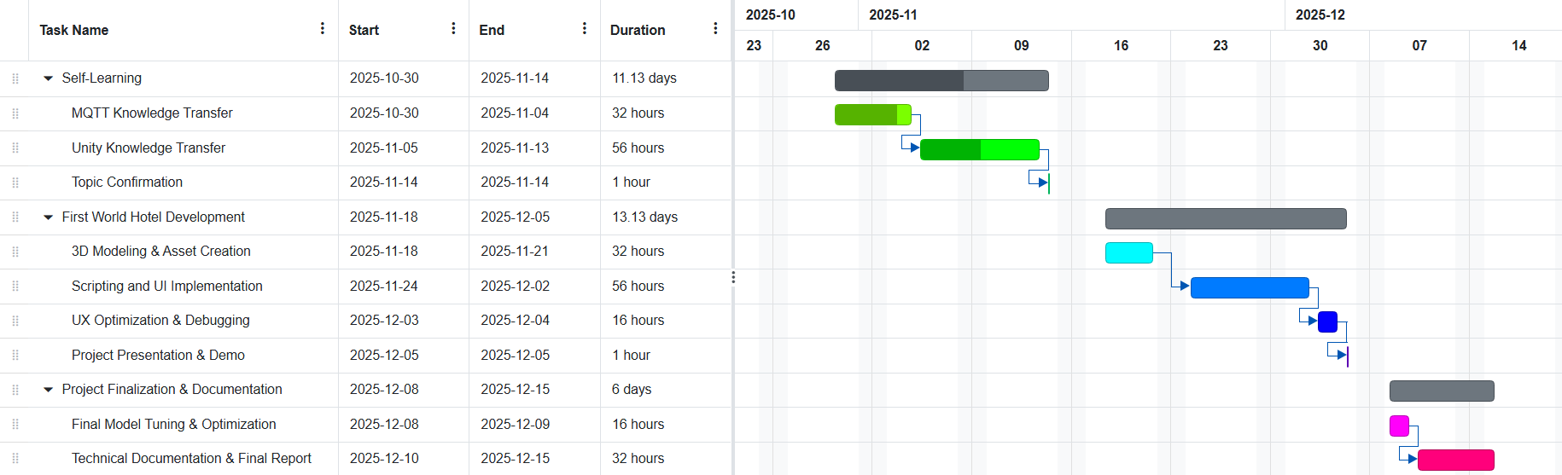
Figure 5.1

Future Improvement and Recommendation
While this prototype successfully demonstrates the core capabilities of a Digital Twin using simulated logic and localhost connectivity, evolving it into a deployment-ready solution for Genting operations requires several strategic enhancements.

Integration of Live IoT Sensor Infrastructure
The current system relies on a Python script to simulate operational parameters such as foot traffic and energy usage. To transition from a proof of concept to an active management tool, the simulation logic should be replaced with real-time data ingestion.
Recommendation:
- Connect the MQTT broker to actual IoT occupancy sensors deployed in the hotel lobby and corridors to visualize live population density.
- Integrate the system with the hotel’s Building Management System (BMS) to display accurate, real-time energy consumption and room status updates rather than mathematically correlated estimates.

Development of High-Fidelity, True-to-Scale Interiors
Currently, only the Standard Room utilizes a "Reference Scale Model" based on physical dimensions, while other room types rely on conceptual layouts. To serve as a reliable tool for potential guests or facility managers, the spatial accuracy must be standardized.
Recommendation:
- Remodel the interior assets for the Deluxe, Triple, and World Club rooms based on exact architectural blueprints to ensure 1:1 scale accuracy.
- Upgrade texture resolution and lighting models to replicate the actual style and layout of physical rooms, decreasing the gap between the digital twin and the real world.

Expansion of Environmental and Geospatial Context
The current Main Menu scene focuses exclusively on the First World Hotel structure. To provide users with better situational awareness and a realistic sense of location, the digital environment should be expanded.
Recommendation:
- Model the surrounding terrain, specifically the mountainous landscape of Genting Highlands, to accurately represent the hotel’s elevation and environment.
- Incorporate adjacent landmarks and infrastructure into the main scene. This will allow users to familiarize themselves with the broader environment and external navigation routes before arrival, enhancing the utility of the application for navigation planning.

Conclusion
This project successfully developed a functional Digital Twin prototype for the First World Hotel, achieving the primary objective of integrating Unity 3D visualization with real-time data communication via the MQTT protocol. By creating a dynamic virtual replica, the system effectively bridges the gap between static digital presentations and the physical reality of the hotel environment.
From a technical perspective, the prototype demonstrates the seamless synchronization of a Python-based backend with a Unity frontend. The successful implementation of the Mosquitto broker allowed for the transmission of both simulated operational data (such as foot traffic and room availability) and live environmental data fetched from the Open-Meteo API. This architecture proves that lightweight messaging protocols can drive high-fidelity 3D visualizations, transforming raw data into an intuitive, spatial interface.
Significantly, the project addresses the limitations of traditional booking platforms by offering a customer-centric solution. Through interactive "First-Person-View" (FPV) exploration, the application allows users to navigate distinct room types, such as the Standard and World Club rooms, providing a realistic sense of scale and layout that static 2D photographs cannot convey. The distinction between "Reference Scale Models" and conceptual layouts further ensures transparency, helping guests manage their expectations regarding room size prior to arrival.
In conclusion, this Digital Twin prototype serves as a foundational proof of concept for modernizing the guest experience at Genting Highlands. While currently relying on simulated logic and localhost connectivity, the established framework is scalable and ready for future integration with actual IoT sensors and cloud-based architecture. This initiative highlights the immense potential of immersive technology in the hospitality sector, offering a smarter, more engaging way for customers to connect with the First World Hotel.

References
Attaran, M., & Celik, B. G. (2023). Digital Twin: Benefits, enabling technologies, and implementation challenges. Decision Analytics Journal, 7, 100215. https://doi.org/10.1016/j.dajour.2023.100215
Sepasgozar, S. M. E., Khan, A. A., Smith, K., & Romero, L. (2023). Digital twins in construction: Architecture, applications, trends and challenges. Buildings, 13(4), 1114. https://doi.org/10.3390/buildings13041114
Al-Sehrawy, R., Kumar, B., & Watson, A. (2024). Digital Twin technology in the built environment: A review of applications, capabilities and challenges. Applied Sciences, 14(5), 101. https://doi.org/10.3390/app14050101

